Sahil Wani

SUID: 466848553

**Getting Started with Visual Studio Code for Streamlit development**

Step 1: Install Python

First things first, we need Python on your machine. Here’s how to get it:

1. Download Python: Download Python from the official website (<https://www.python.org/downloads/>)
2. Run the installer and follow the installation wizard
3. Ensure to check "Add Python to PATH" during installation

Step 2: Install Visual Studio Code

1. Download VS Code from the official website (<https://code.visualstudio.com/>)
2. Run the installer and follow the installation wizard

Step 3: Set Up VS Code for Python Development

1. Open VS Code
2. Install the Python extension:
   * Click on the Extensions icon in the left sidebar
   * Search for "Python"
   * Install the official Python extension by Microsoft

Step 4: Create a New Project

1. Open a new folder in VS Code (File > Open Folder)
2. Create a new file named requirements.txt
3. Add the following line to requirements.txt:

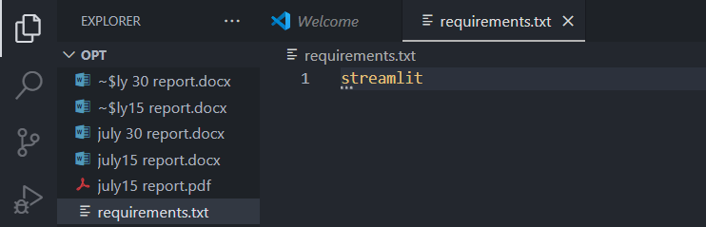

1. Create a new file named app.py

Step 5: Set Up a Virtual Environment

1. Open a new terminal in VS Code (Terminal > New Terminal)
2. Create a virtual environment:



1. Activate the virtual environment:

* On Windows: venv\Scripts\activate

1. Install the required packages:

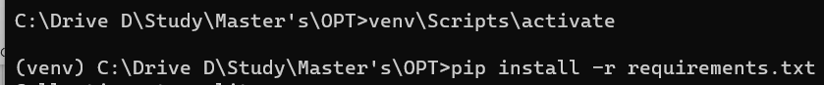

Step 6: Create a Streamlit "Hello World" Application

1. In app.py, add the following code:

1. Save the file

Step 7: Run the Streamlit Application

1. In the terminal, ensure your virtual environment is activated
2. Run the following command:

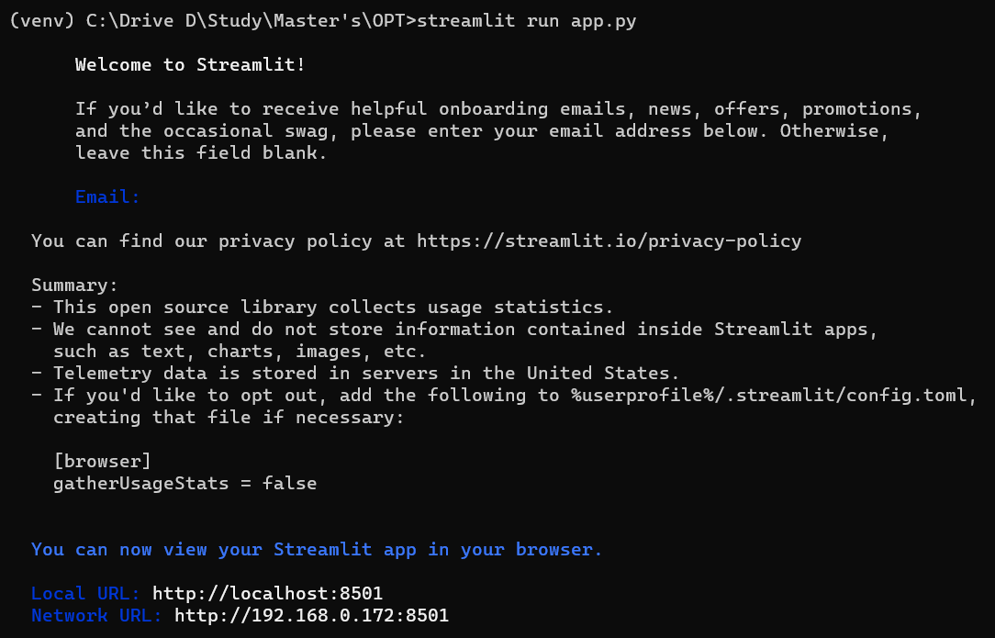

Step 8: View and Interact with Your Application

1. Your default web browser should open automatically, displaying your Streamlit app.
2. You should now see your Streamlit application running in your web browser, displaying "Hello, World!"

Step 9: Closing virtual environment

1. To close streamlit app and virtual environment hit ctrl + c to stop the app and run following command in the terminal to stop the virtual environment:

